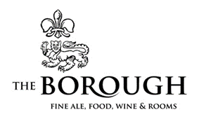

SET MENU – SUMMER 2022
£26.00 for 2 courses and £30.00 for 3 Courses, this includes a glass of Fizz
STARTERS
Garlic & Rosemary Ciabatta, optional cheese (V)
Homemade Soup of the Day, crusty bread (VE)(GF)
Salt & Pepper Calamari, sweet chili dip (GF)
Whipped Goats Cheese and Beetroot, toasted cashew nuts, optional prosciutto (V)(GF)
Balsamic Grilled Steak, Peaches and Blengdale Blue Cheese, balsamic glaze
MAINS
Crispy Sage and Parmesan Pork Loin, dauphinoise potatoes, savoy cabbage, whiskey cream sauce
Crispy Jackfruit Tacos, jackfruit carnitas, refried beans, vegan cheese, Mexican slaw, avocado, vegan spicy mayo (VE) (GF)
Pan Fried Seabass Fillet, lemon rice, Mediterranean roasted vegetables, herb dressing (GF)
Honey & Lime Chicken, noodle stir fry, mango salsa
8oz Cumbrian Sirloin Steak with chips, onion rings, roasted tomato, grilled Portobello mushroom (GF)
(£6 Supplement)
Add blue cheese or peppercorn sauce for £3
DESSERTS
Homemade Sticky Toffee Pudding, Walling’s vanilla ice cream, butterscotch sauce (V)
Homemade Cheesecake of the Day, Walling’s ice cream (V)
Homemade Chocolate Brownie, Walling’s ice cream, chocolate sauce (GF)
Vegan Sorbet Sundae (VE)

