4th High-Pressure Single-Crystal X-Ray Diffraction Summer School
Dominique Laniel, Elena Bykova, Maxim Bykov, Leonid Dubrovinsky, Natalia Dubrovinskaia

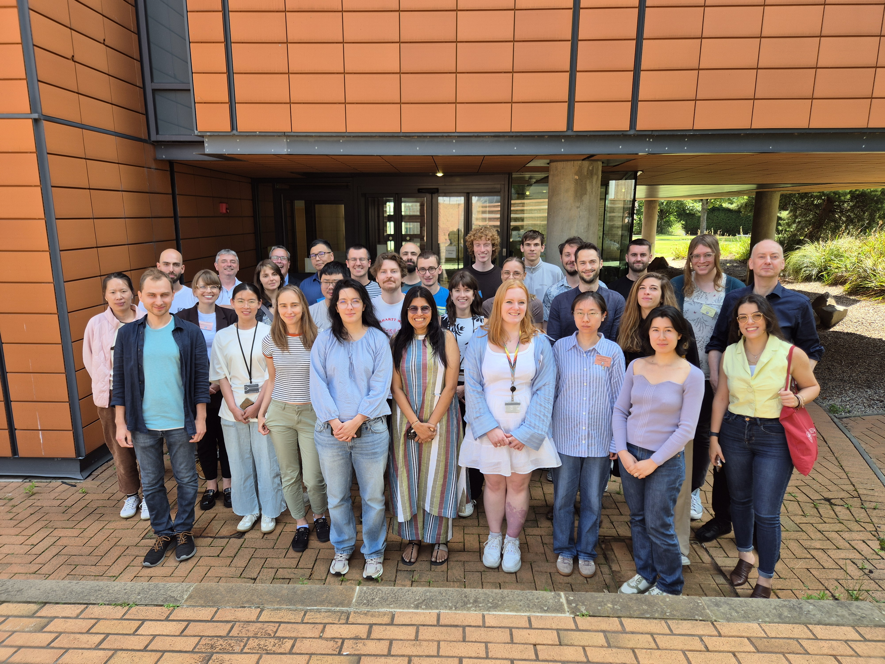
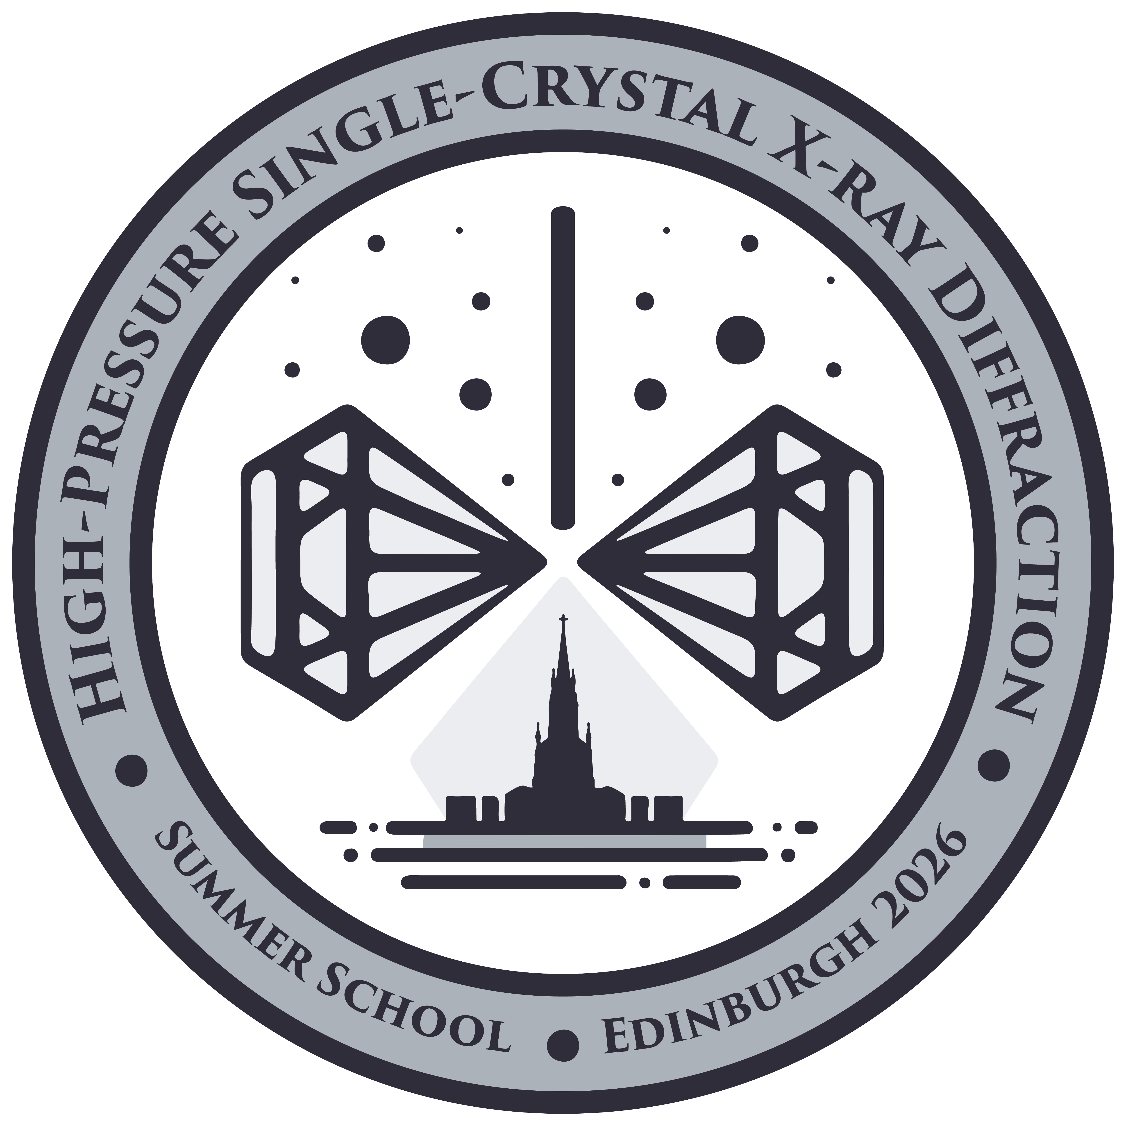
The 4th High-Pressure Single-Crystal X-Ray Diffraction Summer School was held at the James Clerk Maxwell Building of the University of Edinburgh (Edinburgh, Scotland), from July 6th to July 10th 2026 (https://indico.ph.ed.ac.uk/event/282/overview). The School was supported and approved by the IUCr, through the IUCr Commission on High Pressure. A total of 25 participants from ten countries and three continents attended the full week. These participants were provided an accommodation at the University’s Pollock Halls. The School was such a vibrant success that we will hold another one next summer, but this time in Ningbo (China), in 2027.
Group picture taken during the School, with participants and lecturers present. The picture was taken in front of the Centre for Science at Extreme Conditions (CSEC) of the University of Edinburgh.
The intent of the School was to train young and established scientists in the recent methodological advancements in high-pressure single-crystal X-ray diffraction. These new developments enable solving and refining crystal structures from tiny micron- to submicron-sized crystallites confined in diamond anvil cells up to pressures of multiple hundreds of gigapascals (GPa). An overview of the necessary fundamental theoretical and methodological principals, including diamond anvil cell preparation, strategy of experiments, laser heating, introduction to software and SCXRD, were covered through lectures. These were accompanied by nineteen hours of hands-on sessions, where participants were divided into five small groups of five individuals, each with its own instructor, and guided through step-by-step tutorials and examples. At the end of the School, participants were able to perform basic high pressure SCXRD experiments, as well as data processing and interpretation. The lectures and hands-on tutorials were given by a total of eleven experts, with a woman-to-man ratio of 6:5.
To maximize discussions between participants as well as between participants and lecturers, snacks, lunches and dinners were provided onsite for the complete duration of the School. All participants were requested to bring a poster presenting their research, which were shown and displayed during two poster sessions. Moreover, extracurricular activities took place during three evenings, namely a whisky tasting, a walking tour of Edinburgh and a ceilidh—a traditional Scottish group dancing.
During the last day of the School, the IUCr awardees were given their certificate. The participants were also requested to fill out an online survey to gauge their satisfaction and identify aspects to improve for next editions of the School. Overall, their response was overwhelming positive. Indeed, all participants that took part in the survey said they would recommend the School to others, while 88.9% and 11.1% rated their overall impression of the School as “Excellent” or “Good”, respectively. Among all surveyed aspects, the one with the least positive feedback was meals and refreshments, for which 50% of the participants were either “Very satisfied” but 50% were “Satisfied”.
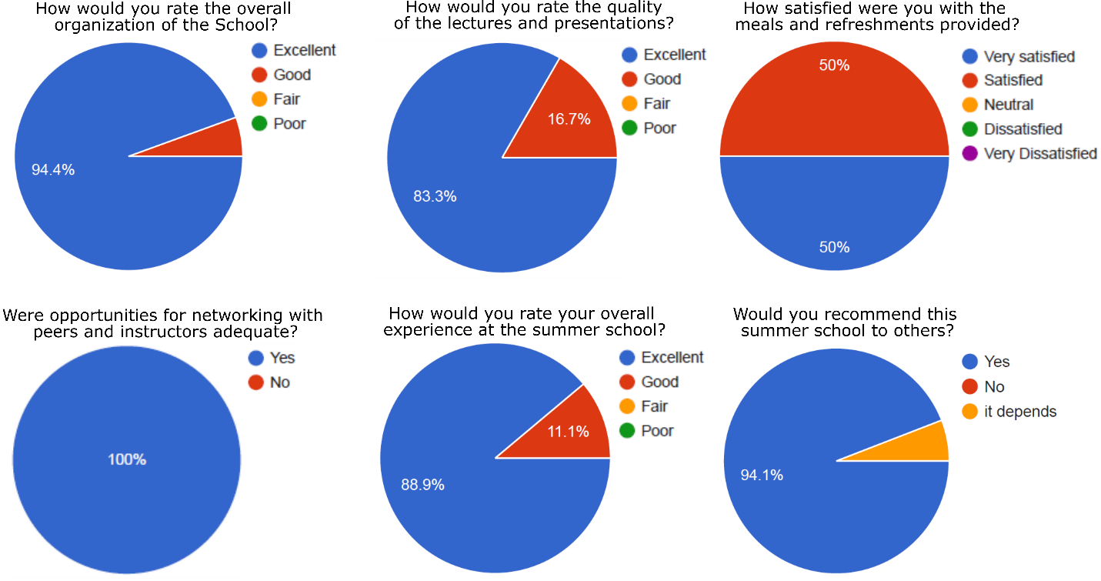
Questions and pie chart representations of the answers obtained from the survey filled out by the attendees at the end of the School.

Given the increasing importance diamond anvil cell single-crystal X-ray diffraction of polycrystalline samples methodology, as well as the very positive feedback received from participants, we are confident that new participants will attend the next edition in Ningbo (China), which will undoubtedly be just as successful. Looking forward to summer 2027…!

